Parameters to consider:

* video or image
  + Recalculation time
* **Density of cars** (*4 ready queues*)
* Waiting time **–** used to avoid starvation (*Fairness*)
* Number of cars crossing intersection **–** needs to be maximized (*Efficiency*)
* Acceptance capacity of roads after intersection (*Efficiency and deadlock avoidance*)
* Priority vehicles (*Priority i.e., the algorithm is preemptive)*
  + Emergency vehicles **–** consider using the left most lane’s light
  + Priority vehicles / interrupt due to command from authorities

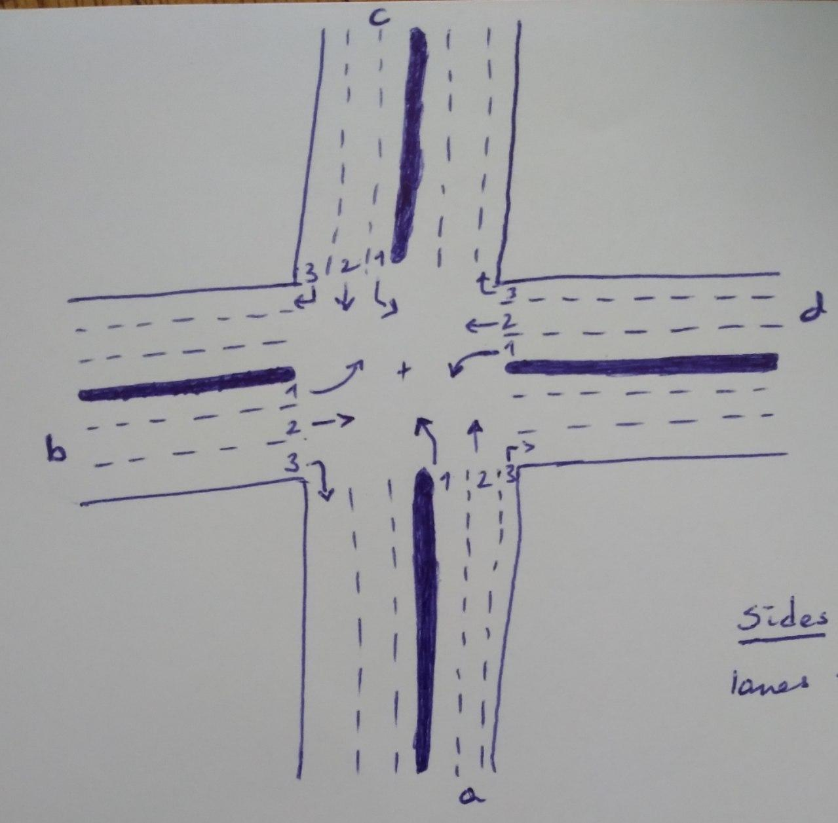

Parameter choice and decision:

* Video – To make it real time and be able interrupt because of emergency vehicles
* Max waiting time –> going straight -

–> turning left -

* Cars crossing intersection – simultaneously release two lanes. Possible combinations:

1. a2 – c2 / b2 – d2
2. a1 – a2 / b1 – b2 / c1 – c2 / d1 – d2 / a1 – d2 / b1 – a2 / c1 – b2 /

d1 – c2

1. a1 – c1 / b1 – d1

* If lane x’s waiting time is up

1. But no sufficient space after intersection, put it in critical waiting zone and allow other lanes to pass until space is available.
2. Small space is available, release cars proportional to available space. Here consider not resetting this lane’s waiting time to zero.

* Interrupt:
  + - Cache current traffic light data and get into interrupt mode

1. Emergency vehicle – Either allow left most lane of side with emergency vehicle (or just the whole side) and wait until emergency vehicle has crossed intersection
2. Priority vehicle (Authorities command) – wait until time allocated by authorities

runs out